25.37: a) Now the current flows clockwise since both batteries point in that direction:
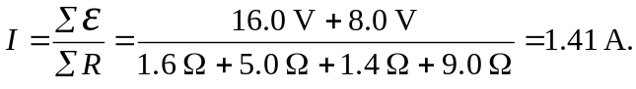
b)
c)
d)
